**Assignment 1**

**Group: DWDM19G04**

**Roll Numbers: 2016BTECS00063, 2016BTECS00081, 2016BTECS00103**

**Batch: B7**

**Date: 24th August, 2019**

**Title: Data Warehousing**

**Problem Statement:**

In this lab you will create a toy data warehouse and learn how to use SQL aggregation functions for OLAP purposes.

**Theory:**

**Data Warehouse:**A large store of data accumulated from a wide range of sources within a company and used to guide management decisions.

**ROLLUP:** ROLLUP enables a SELECT statement to calculate multiple levels of subtotals across a specified group of dimensions. It also calculates a grand total. The action of ROLLUP is straightforward: it creates subtotals that roll up from the most detailed level to a grand total, following a grouping list specified in the ROLLUP clause. ROLLUP takes as its argument an ordered list of grouping columns. First, it calculates the standard aggregate values specified in the GROUP BY clause. Then, it creates progressively higher-level subtotals, moving from right to left through the list of grouping columns. Finally, it creates a grand total. ROLLUP creates subtotals at n+1 levels, where n is the number of grouping columns.

An example:

SELECT DIM1, DIM2, SUM(MEASURE)  
FROM FACTTAB  
GROUP BY ROLLUP (DIM1, DIM2)

ORDER BY DIM1, DIM2

**CUBE:** CUBE takes a specified set of grouping columns and creates subtotals for all of their possible combinations. In terms of multidimensional analysis, CUBE generates all the subtotals that could be calculated for a data cube with the specified dimensions. If n columns are specified for a CUBE, there will be 2 to the n combinations of subtotals returned.

An example:  
SELECT DIM1, DIM2, SUM(MEASURE)  
FROM FACTTAB  
GROUP BY CUBE(DIM1, DIM2)  
ORDER BY DIM1, DIM2

**Output:**

Activity 1. Create a Data Warehouse

CREATE TABLE DIM_ITEM

(

ID_ITEM INT PRIMARY KEY,

ITEMNAME CHAR(20),

COLOR CHAR(10),

PRICE REAL

);

INSERT INTO DIM_ITEM VALUES(1,'LAPTOP','RED',300);

INSERT INTO DIM_ITEM VALUES(2,'BALL','BLUE',500);

INSERT INTO DIM_ITEM VALUES(3,'MOBILE','ORANGE',200);

INSERT INTO DIM_ITEM VALUES(4,'WALLET','GREY',150);

INSERT INTO DIM_ITEM VALUES(5,'BAT','GREEN',400);

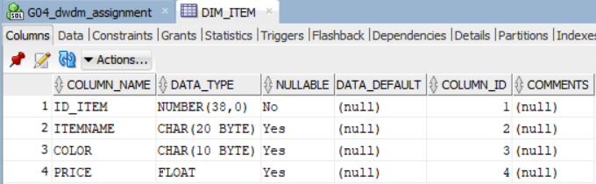

CREATE TABLE DIM_TIME(

ID_TIME INT PRIMARY KEY,

REALDATE CHAR(8),

YEARMONTH CHAR(8)

);

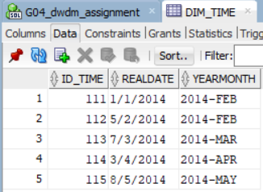

INSERT INTO DIM_TIME VALUES(111,'1/1/2014','2014-FEB');

INSERT INTO DIM_TIME VALUES(112,'5/2/2014','2014-FEB');

INSERT INTO DIM_TIME VALUES(113,'7/3/2014','2014-MAR');

INSERT INTO DIM_TIME VALUES(114,'3/4/2014','2014-APR');

INSERT INTO DIM_TIME VALUES(115,'8/5/2014','2014-MAY');

CREATE TABLE DIM_PLACE

(

ID_PLACE INT PRIMARY KEY,

SHOPNAME CHAR(20),

CITY CHAR(10),

COUNTRY CHAR(3)

);

INSERT INTO DIM_PLACE VALUES(11,'ARYA','PUNE','IND');

INSERT INTO DIM_PLACE VALUES(12,'SHREE','MUMBAI','IND');

INSERT INTO DIM_PLACE VALUES(13,'DIABLO','CHICAGO','USA');

INSERT INTO DIM_PLACE VALUES(14,'SAFA','SANGLI','IND');

INSERT INTO DIM_PLACE VALUES(15,'HAMLEY','NAGPUR','IND');

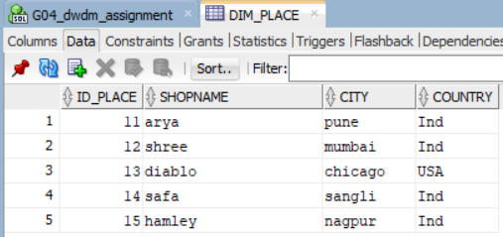

CREATE TABLE FACT_SALE(

ID_SALE CHAR(5) PRIMARY KEY,

ID_ITEM INT,

ID_PLACE INT,

ID_TIME INT,

FOREIGN KEY (ID_ITEM) REFERENCES DIM_ITEM(ID_ITEM),

FOREIGN KEY (ID_PLACE) REFERENCES DIM_PLACE(ID_PLACE),

FOREIGN KEY (ID_TIME) REFERENCES DIM_TIME(ID_TIME),

TOTAL REAL);

INSERT INTO FACT_SALE VALUES('1121',1,15,111,5200);

INSERT INTO FACT_SALE VALUES('1122',2,11,112,1500);

INSERT INTO FACT_SALE VALUES('1123',3,14,113,5000);

INSERT INTO FACT_SALE VALUES('1124',4,13,114,1300);

INSERT INTO FACT_SALE VALUES('1125',5,12,115,2500);

INSERT INTO FACT_SALE VALUES('1126',4,11,111,3000);

INSERT INTO FACT_SALE VALUES('1127',3,12,112,3500);

INSERT INTO FACT_SALE VALUES('1128',5,13,113,2700);

INSERT INTO FACT_SALE VALUES('1129',2,14,114,1800);

INSERT INTO FACT_SALE VALUES('1130',1,15,115,10000);

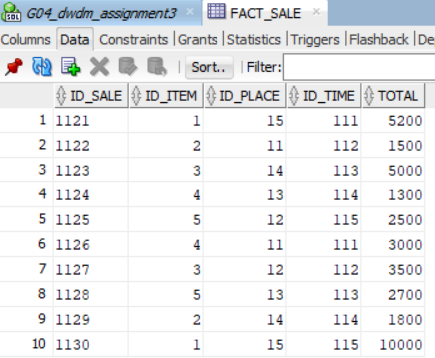

Activity 2. Aggregation with ROLLUP

1) Using ROLLUP keyword, construct a query that calculates subtotals of the FACT_Sale.Total field across the FACT_Sale.ID_Item and FACT_Sale.ID_Place fields:

SELECT ID_ITEM,ID_PLACE,SUM(TOTAL) AS TOTAL

FROM FACT_SALE

GROUP BY ROLLUP (ID_ITEM,ID_PLACE)

ORDER BY ID_ITEM,ID_PLACE;

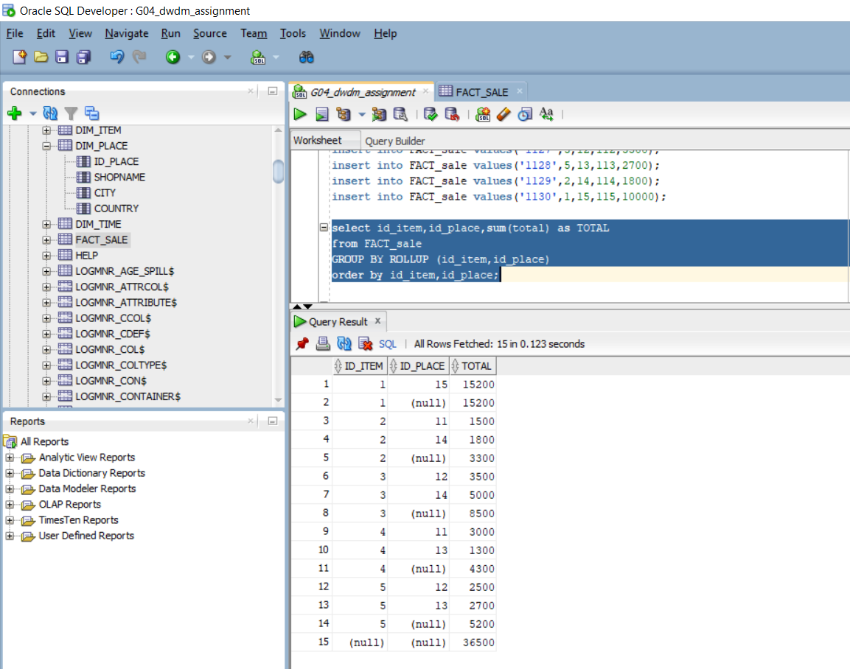

2) Modify the query above to calculate subtotals across the Dim_Item.ItemName and Dim_Place.ShopName fields.

SELECT B.ITEMNAME,C.SHOPNAME,SUM(A.TOTAL) AS TOTAL

FROM FACT_SALE A,DIM_ITEM B,DIM_PLACE C

WHERE A.ID_ITEM=B.ID_ITEM AND A.ID_PLACE=C.ID_PLACE

GROUP BY ROLLUP (B.ITEMNAME,C.SHOPNAME)

ORDER BY B.ITEMNAME,C.SHOPNAME;

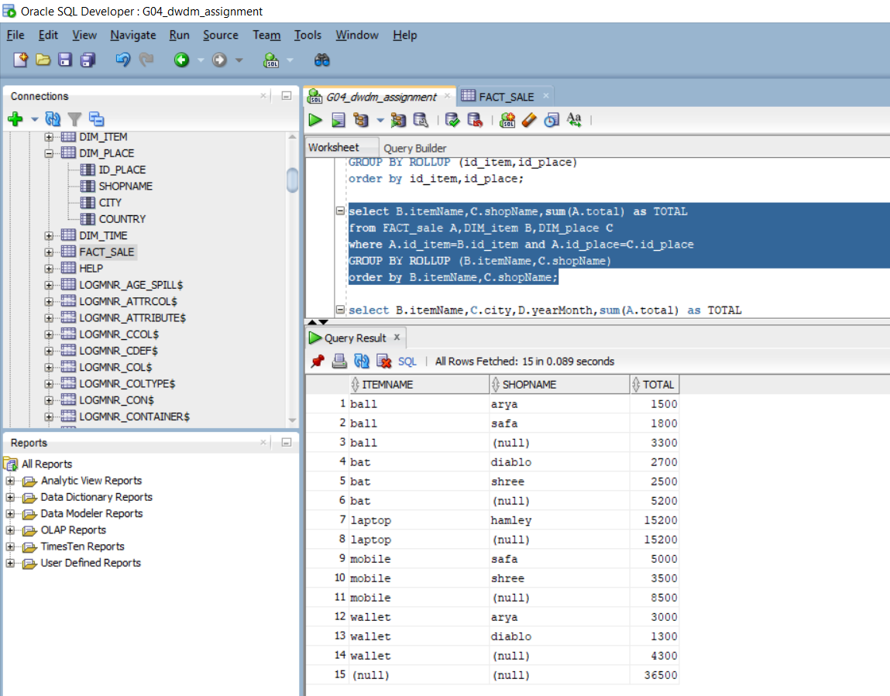

3) Using ROLLUP keyword, construct a query that calculates subtotals of the

FACT_Sale.Total field across the DIM_Item.ItemName, DIM_Place.City and

FACT_Time.YearMonth fields.

SELECT B.ITEMNAME,C.CITY,D.YEARMONTH,SUM(A.TOTAL) AS TOTAL

FROM FACT_SALE A,DIM_ITEM B,DIM_PLACE C,DIM_TIME D

WHERE A.ID_ITEM=B.ID_ITEM AND A.ID_PLACE=C.ID_PLACE AND A.ID_TIME = D.ID_TIME

GROUP BY ROLLUP (B.ITEMNAME,C.CITY,D.YEARMONTH)

ORDER BY B.ITEMNAME,C.CITY,D.YEARMONTH;

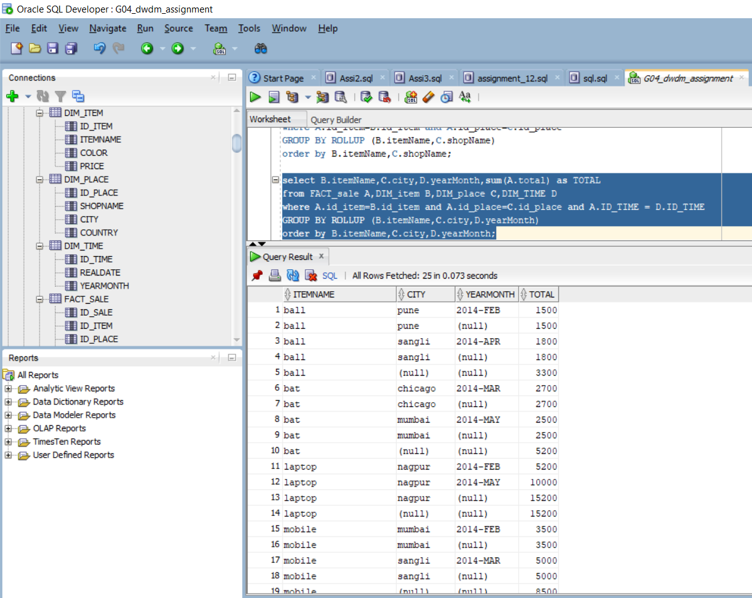

4) Using ROLLUP keyword, construct a query that calculates subtotals of the

FACT_Sale.Total field across the DIM_Item.Color, DIM_Place.Country and

FACT_Time.YearMonth fields.

SELECT B.COLOR,C.COUNTRY,D.YEARMONTH,SUM(A.TOTAL) AS TOTAL

FROM FACT_SALE A,DIM_ITEM B,DIM_PLACE C,DIM_TIME D

WHERE A.ID_ITEM=B.ID_ITEM AND A.ID_PLACE=C.ID_PLACE AND A.ID_TIME = D.ID_TIME

GROUP BY ROLLUP (B.COLOR,C.COUNTRY,D.YEARMONTH)

ORDER BY B.COLOR,C.COUNTRY,D.YEARMONTH;

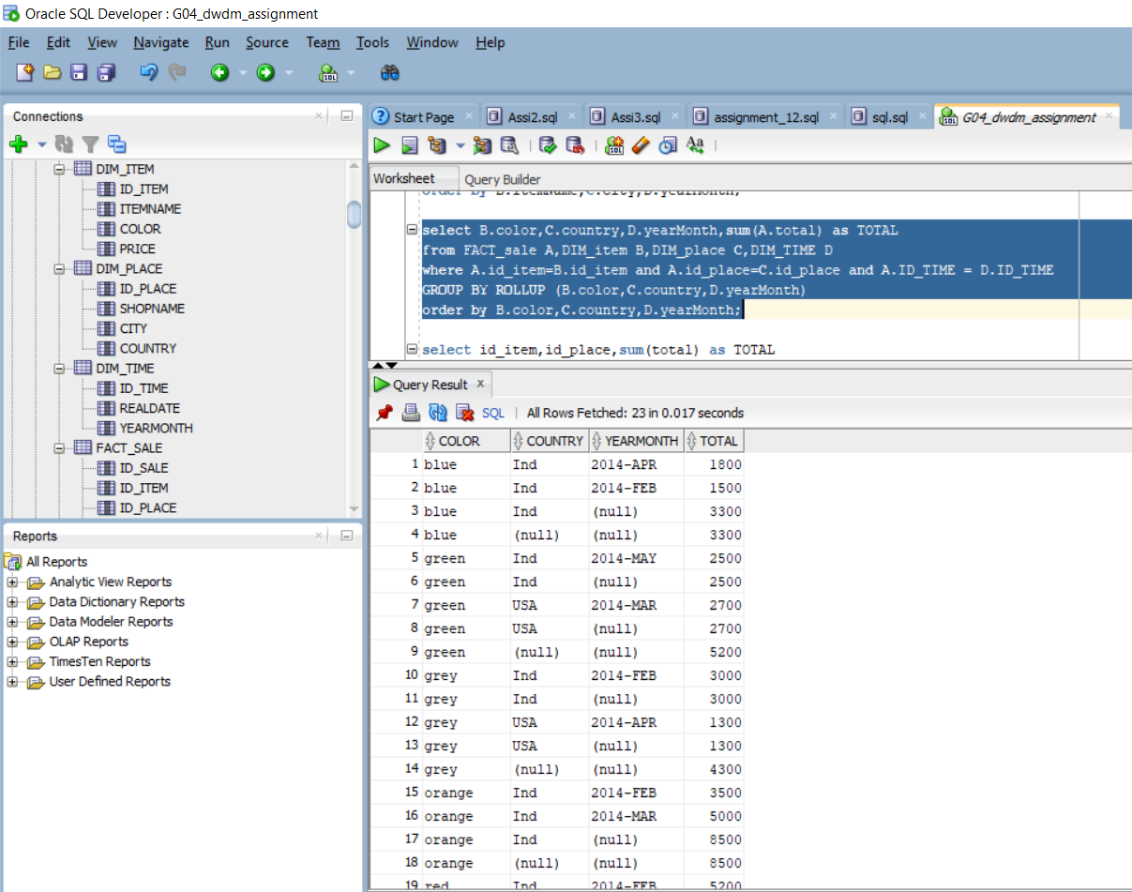

Activity 3. Aggregation with CUBE

1) Using CUBE keyword, construct a query that calculates subtotals of the

FACT_Sale.Total field across the FACT_Sale.ID_Item and

FACT_Sale.ID_Place fields.

SELECT ID_ITEM,ID_PLACE,SUM(TOTAL) AS TOTAL

FROM FACT_SALE

GROUP BY CUBE (ID_ITEM,ID_PLACE)

ORDER BY ID_ITEM,ID_PLACE;

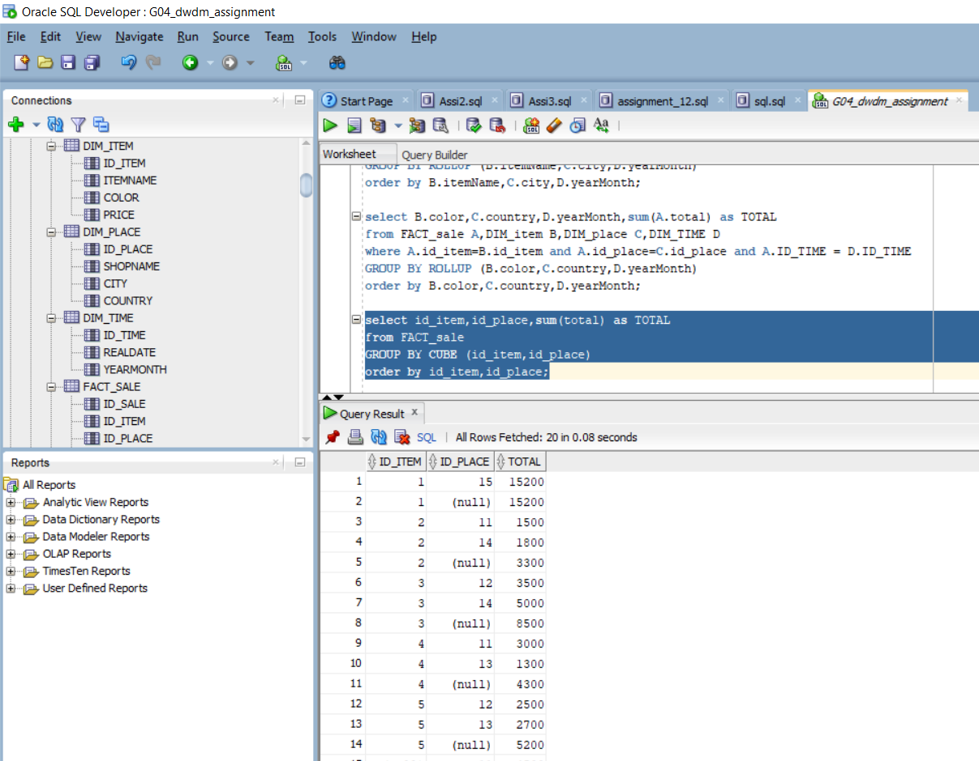

2) Modify the query above to calculate subtotals across the Dim_Item.ItemName

and Dim_Place.ShopName fields.

SELECT B.ITEMNAME,C.SHOPNAME,SUM(A.TOTAL) AS TOTAL

FROM FACT_SALE A,DIM_ITEM B,DIM_PLACE C

WHERE A.ID_ITEM=B.ID_ITEM AND A.ID_PLACE=C.ID_PLACE

GROUP BY CUBE (B.ITEMNAME,C.SHOPNAME)

ORDER BY B.ITEMNAME,C.SHOPNAME;

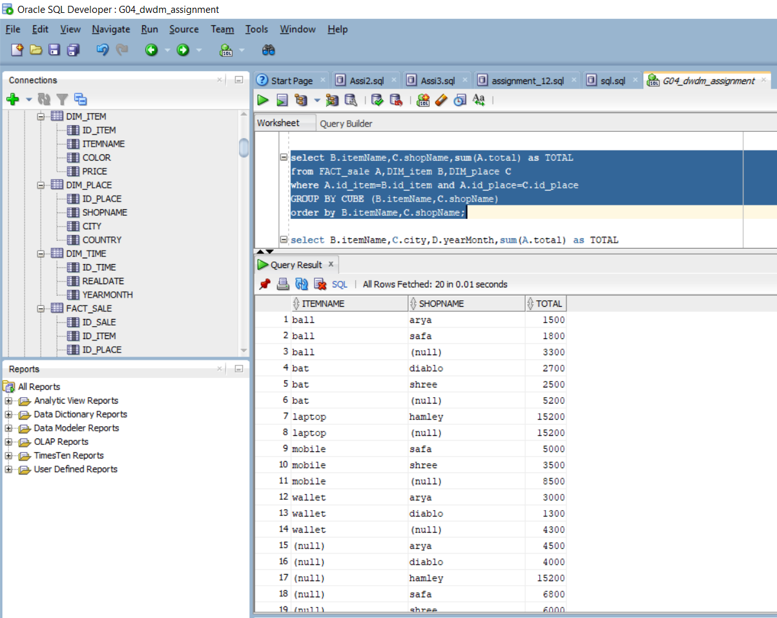

5) Using CUBE keyword, construct a query that calculates subtotals of the

FACT_Sale.Total field across the DIM_Item.ItemName, DIM_Place.City and

FACT_Time.YearMonth fields.

SELECT B.ITEMNAME,C.CITY,D.YEARMONTH,SUM(A.TOTAL) AS TOTAL

FROM FACT_SALE A,DIM_ITEM B,DIM_PLACE C,DIM_TIME D

WHERE A.ID_ITEM=B.ID_ITEM AND A.ID_PLACE=C.ID_PLACE AND A.ID_TIME = D.ID_TIME

GROUP BY CUBE (B.ITEMNAME,C.CITY,D.YEARMONTH)

ORDER BY B.ITEMNAME,C.CITY,D.YEARMONTH;

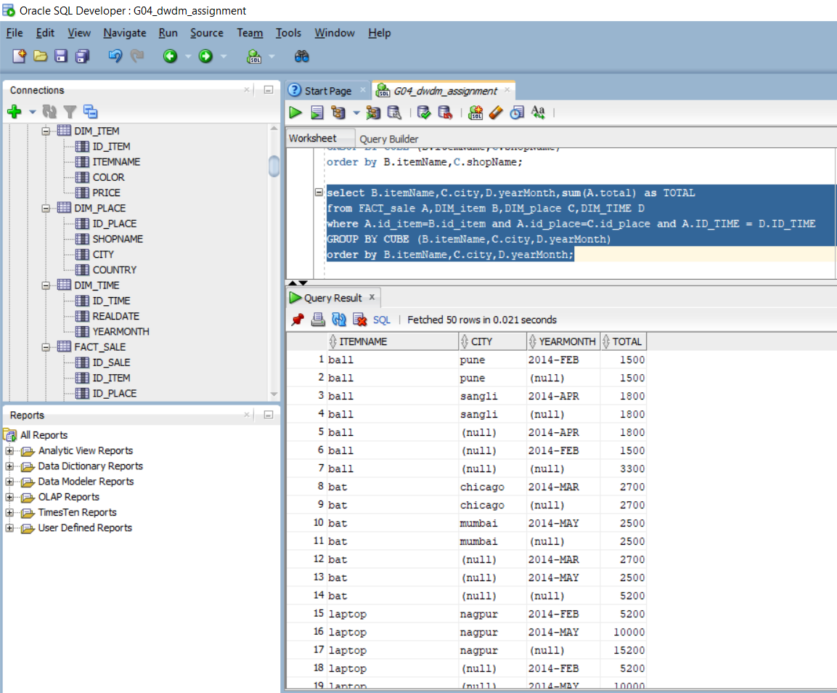

6) Using CUBE keyword, construct a query that calculates subtotals of the

FACT_Sale.Total field across the DIM_Item.Color, DIM_Place.Country and

FACT_Time.YearMonth fields.

SELECT B.COLOR,C.COUNTRY,D.YEARMONTH,SUM(A.TOTAL) AS TOTAL

FROM FACT_SALE A,DIM_ITEM B,DIM_PLACE C,DIM_TIME D

WHERE A.ID_ITEM=B.ID_ITEM AND A.ID_PLACE=C.ID_PLACE AND A.ID_TIME = D.ID_TIME

GROUP BY CUBE (B.COLOR,C.COUNTRY,D.YEARMONTH)

ORDER BY B.COLOR,C.COUNTRY,D.YEARMONTH;

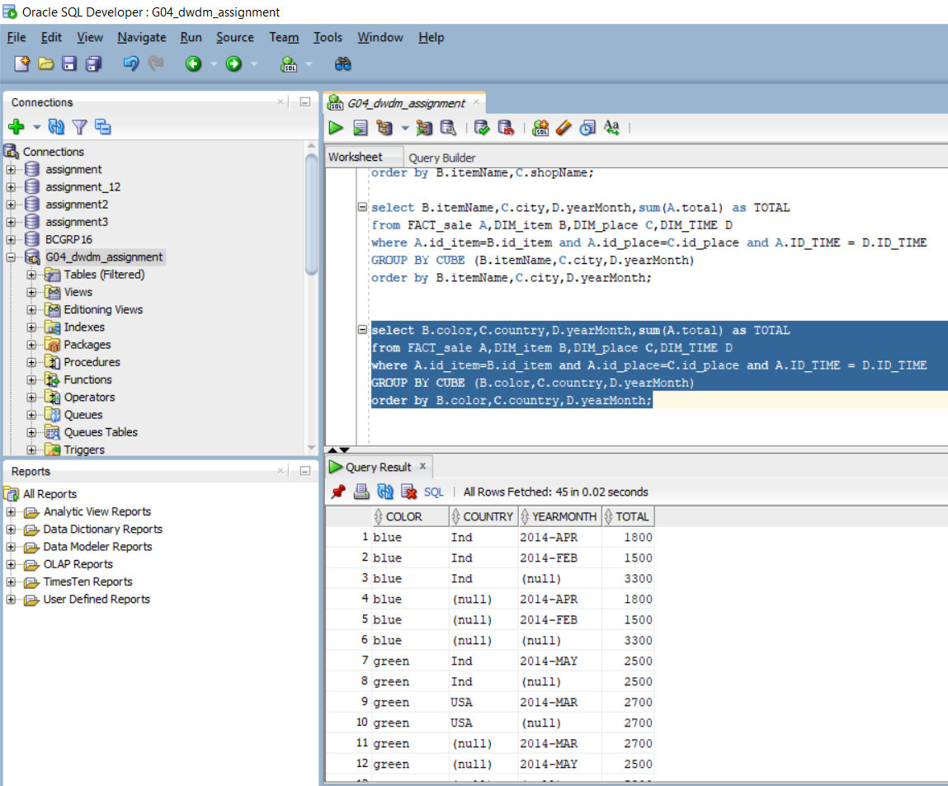

**Conclusion**:

We learnt how to design a star schema database with ROLL-UP and CUBE operations.